Course Name:  Course Code: | Digital Logic Design Laboratory (DLDL)  316U06L202 | Semester: | II
Date of Performance: | 11/ 03 /2026 | Batch No: | A1
Student Name: | Arav Arun | Roll No: | 16010125013
Faculty Sign & Date: |  | Grade/Marks: | / 2
Experiment No: 8
Title: Implementation of 3-bit Asynchronous Counter using JK Flip-Flops
Aim and Objective of the Experiment:
Design and verify the 3 - Bit Asynchronous Counter using JK flip flops. Design and implement sequential logic circuits and their applications

COs to be achieved:
CO4: Implement sequential logic circuits and applications using MSI devices.
CO5: Understand basic principles required for advanced Digital Design

ICs Used: 7476
Asynchronous Counter Design Steps:

- Determine the Modulus (MOD)
  - Decide how many states the counter should have
  - Example: MOD-8 → counts from 0 to 7
- Choose Type of Flip-Flop
  - Common choices: JK Flip-Flop or T Flip-Flop
  - For toggling:
    - JK → J = K = 1
    - T → T = 1
- Connect Flip-Flops in Ripple Fashion
  - First flip-flop gets external clock
  - Each next flip-flop gets clock from previous flip-flop’s output (Q)
- Set Initial Conditions
  - Reset all flip-flops to 0 (using clear/reset inputs)
- Design for Required MOD (if not power of 2)
  - Add logic gates (AND/NAND) to reset counter at desired count
  - Example: MOD-6 → reset when count reaches 6 (110)
- Draw the Circuit Diagram
  - Show:
    - Flip-flops
    - Clock connections (ripple)
    - Reset logic (if any)
- Verify Counting Sequence
  - Check output states (Q0, Q1, Q2…)
  - Ensure correct counting (binary sequence or truncated sequence)
- Logic Diagram: 3-bit Asynchronous counter using J-K Flip-flop
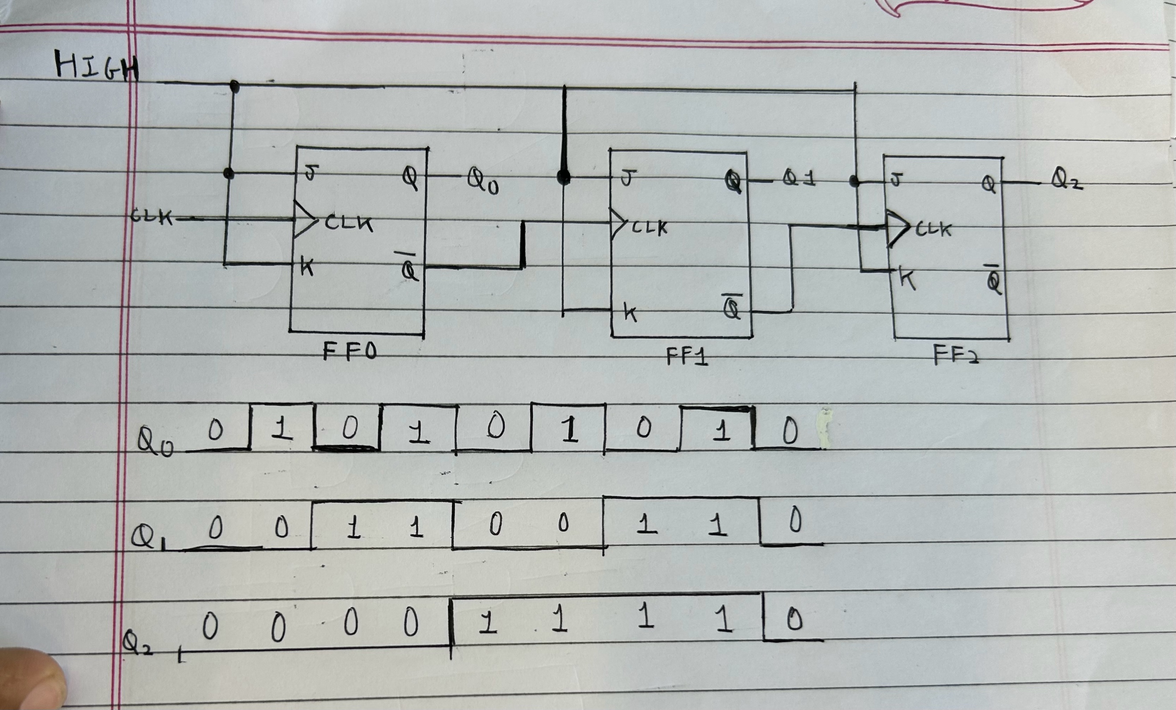

Truth Table: Asynchronous Counter

Clock State | Outputs
S | Q2 | Q1 | Q0
0 | 0 | 0 | 0
1 | 0 | 0 | 1
2 | 0 | 1 | 0
3 | 0 | 1 | 1
4 | 1 | 0 | 0
5 | 1 | 0 | 1
6 | 1 | 1 | 0
7 | 1 | 1 | 1

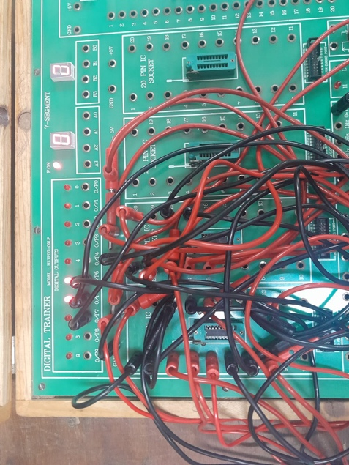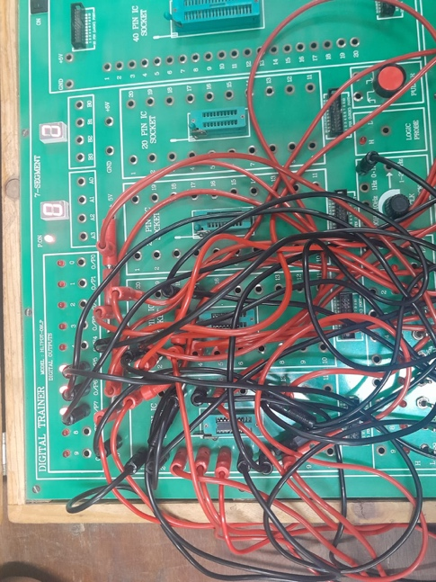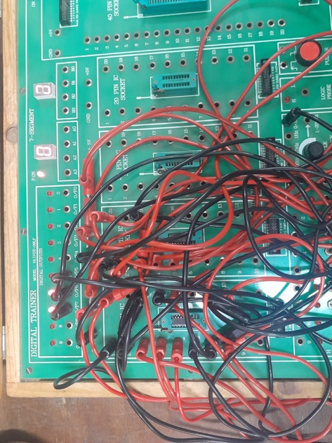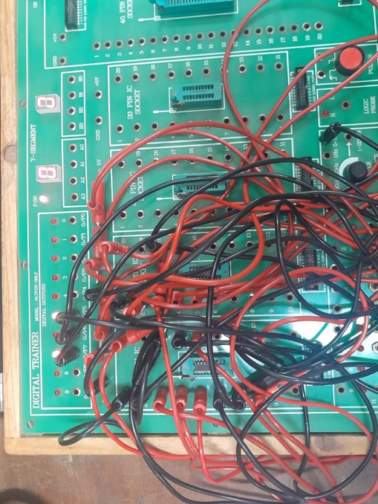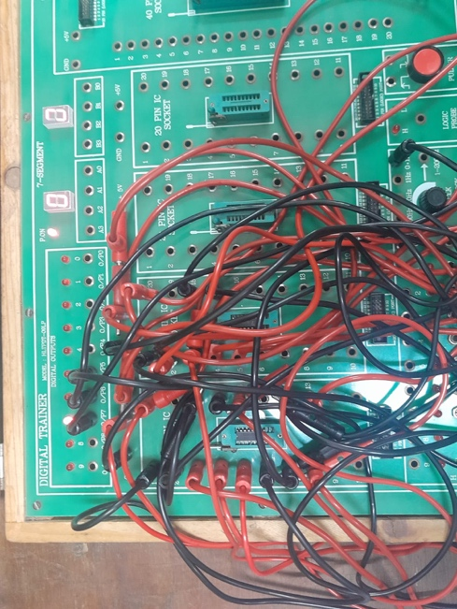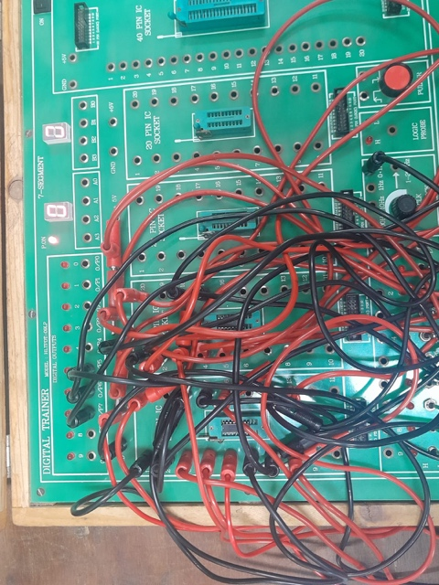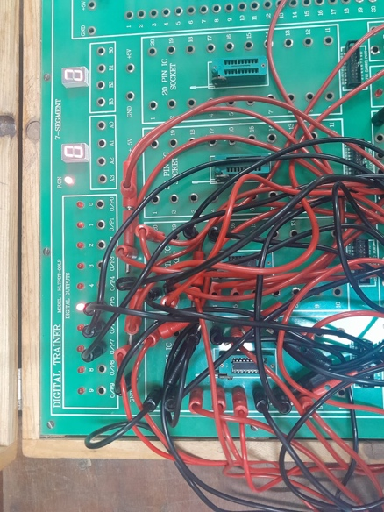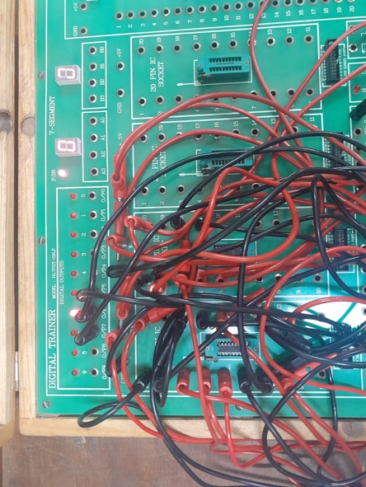
Conclusion:
In this experiment, we successfully designed and verified a 3-bit Asynchronous (Ripple) Counter using JK
flipflops. We understood how the output of one flip-flop acts as the clock input for the next stage, resulting in a
sequential counting operation. The practical implementation helped us observe the ripple effect and timing delay
between outputs. Through this experiment, we gained a clear understanding of sequential logic circuits and their
applications in digital systems such as counters and frequency division.

Signature of faculty in-charge with Date:

